ITL 3 PRACTICAL - 02

**AIM**

**Write a program to redirect a request using a dynamic approach.**

**Servlet technology is used to create a web application (resides at server side and generates a dynamic web page).**

**Servlet technology is robust and scalable because of java language. Before Servlet, CGI (Common Gateway Interface) scripting language was common as a server-side programming language. However, there were many disadvantages to this technology. We have discussed these disadvantages below.**

**There are many interfaces and classes in the Servlet API such as Servlet, GenericServlet, HttpServlet, ServletRequest, ServletResponse, etc.**

**Servlet can be described in many ways, depending on the context.**

* **Servlet is a technology which is used to create a web application.**
* **Servlet is an API that provides many interfaces and classes including documentation.**
* **Servlet is an interface that must be implemented for creating any Servlet.**
* **Servlet is a class that extends the capabilities of the servers and responds to the incoming requests. It can respond to any requests.**
* **Servlet is a web component that is deployed on the server to create a dynamic web page.**

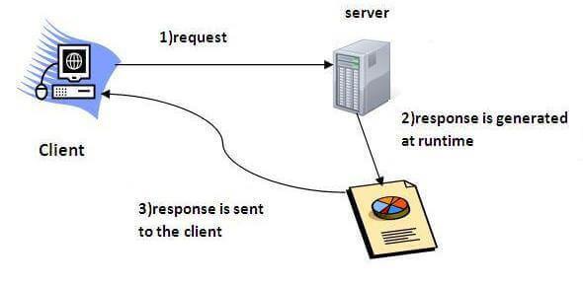

**IMPLEMENTATION:-**

**package com.mkyong.http;**

**import java.io.BufferedReader;**

**import java.io.InputStreamReader;**

**import java.net.HttpURLConnection;**

**import java.net.URL;**

**public class HttpRedirectExample {**

**public static void main(String[] args) {**

**try {**

**String url = "http://www.twitter.com";**

**URL obj = new URL(url);**

**HttpURLConnection conn = (HttpURLConnection) obj.openConnection();**

**conn.setReadTimeout(5000);**

**conn.addRequestProperty("Accept-Language", "en-US,en;q=0.8");**

**conn.addRequestProperty("User-Agent", "Mozilla");**

**conn.addRequestProperty("Referer", "google.com");**

**System.out.println("Request URL ... " + url);**

**boolean redirect = false;**

**// normally, 3xx is redirect**

**int status = conn.getResponseCode();**

**if (status != HttpURLConnection.HTTP_OK) {**

**if (status == HttpURLConnection.HTTP_MOVED_TEMP**

**|| status == HttpURLConnection.HTTP_MOVED_PERM**

**|| status == HttpURLConnection.HTTP_SEE_OTHER)**

**redirect = true;**

**}**

**System.out.println("Response Code ... " + status);**

**if (redirect) {**

**// get redirect url from "location" header field**

**String newUrl = conn.getHeaderField("Location");**

**// get the cookie if need, for login**

**String cookies = conn.getHeaderField("Set-Cookie");**

**// open the new connnection again**

**conn = (HttpURLConnection) new URL(newUrl).openConnection();**

**conn.setRequestProperty("Cookie", cookies);**

**conn.addRequestProperty("Accept-Language", "en-US,en;q=0.8");**

**conn.addRequestProperty("User-Agent", "Mozilla");**

**conn.addRequestProperty("Referer", "google.com");**

**System.out.println("Redirect to URL : " + newUrl);**

**}**

**BufferedReader in = new BufferedReader(**

**new InputStreamReader(conn.getInputStream()));**

**String inputLine;**

**StringBuffer html = new StringBuffer();**

**while ((inputLine = in.readLine()) != null) {**

**html.append(inputLine);**

**}**

**in.close();**

**System.out.println("URL Content... \n" + html.toString());**

**System.out.println("Done");**

**} catch (Exception e) {**

**e.printStackTrace();**

**}**

**}**

**}**

**Output**

**Request URL ... http://www.twitter.com**

**Response Code ... 301**

**Redirect to URL : https://twitter.com/**

**URL Content...**

**<!DOCTYPE html><!--[if IE 8]><html class= // twitter.com url content...**